Long Division
Below is the process written out in full. (It is what is called an "algorithmic process").
You will often see other versions. These are generally just a shortened version
of the process below.
Let's see how it is done with:
425 ÷ 25
There are two definitions we must make first.
- the number to be divided into is known as the dividend (425 from above)
- The number which divides the other number is known as the divisor (25 from above)
Note: You can also see this done in Long Division Animation

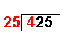 | 4 ÷ 25 = 0 remainder 4 | The first number of the dividend is divided by the divisor.
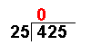 |  | The whole number result is placed at the top. Any remainders are ignored at this point.
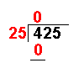 | 25 × 0 = 0 | The answer from the first operation is multiplied by the divisor. The result is placed under the number divided into.
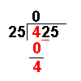 | 4 – 0 = 4 | Now we subtract the bottom number from the top number.
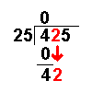 |  | Bring down the next number of the dividend.
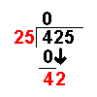 | 42 ÷ 25 = 1 remainder 17 | Divide this number by the divisor.
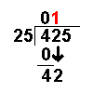 |  | The whole number result is placed at the top. Any remainders are ignored at this point.
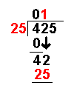 | 25 × 1 = 25 | The answer from the above operation is multiplied by the divisor. The result is placed under the last number divided into.
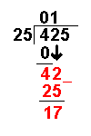 | 42 – 25 = 17 | Now we subtract the bottom number from the top number.
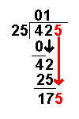 |  | Bring down the next number of the dividend.
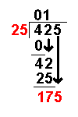 | 175 ÷ 25 = 7 remainder 0 | Divide this number by the divisor.
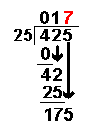 |  | The whole number result is placed at the top. Any remainders are ignored at this point.
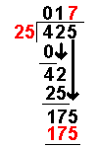 | 25 × 7 = 175 | The answer from the above operation is multiplied by the divisor. The result is placed under the number divided into.
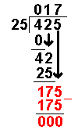 | 175 – 175 = 0 | Now we subtract the bottom number from the top number.
 |  | There are no more numbers to bring down. The answer must be 17

